**JAYPEE INSTITUTE OF INFORMATION TECHNOLOGY, NOIDA**

**2019-20**

**B.TECH, CSE**

**MINOR-2 PROJECT REPORT**

**INTEGRATING ADVANCE TECHNOLOGIES IN THE FIELD OF AGRICULTURE**

**SUBMITTED BY:- MENTOR SUBMITTED TO:-**

**Chitrank Mishra Mr. Ashish Mishra**

**(17103103)**

**Aman Khare**

**(17103048)**

**Dharmesh Pratap Singh**

**(17103279)**

**ACKNOWLEDGEMENT**

We thank our mentor Mr. Ashish Mishra , Deptt of CSE, Jaypee Institute of Information Technology, Sector-62, Noida. We express our sincere gratitude towards him, as his guidance, encouragement, suggestions and constructive criticism have contributed immensely to the evolution of ideas on the project.

Turning this idea into a project wouldn’t have been possible if he hadn’t provided us with the knowledge he possesses and help us to get the best conclusion possible.

Aman Khare

Chitrank Mishra

Dharmesh Pratap Singh

**CONTENT LIST**

**1. INTRODUCTION**

Agriculture is the root source of life for a greater part of the Indian population. 58% of the population of our country relies on agriculture. India is planned to increase the crop cultivation by a massive rise of 200% by 2020. These huge numbers and this level of production requires tremendous resources, the highest variety of seeds, most modern and healthy methods of cultivation, and huge dependence on technological development.

Agriculture is still a growing field for research and development on technological upfront. India ranks second worldwide in farm outputs. As per 2018, agriculture employed 50% of the Indian workforce and contributed 17-18% to the country's GDP. India ranks first in the world with the highest net cropped area followed by the US and China. India is ranked under the world's five largest producers of over 80% of agricultural produce items, including many cash crops such as coffee and cotton, in 2010.

Government of India has taken a huge initiative to create awareness among farmers to switch to the modern methods of farming, while they are investing in organizing hundreds of seminars to educate the cultivators about the growing technology, they are also organizing many programs nationwide to attract the brilliant minds to be a part of this initiative. Through such programs, the government is trying to identify and give up new classes of machinery and inventions to support sustainable farming.

Innovation is more important in agriculture than ever before. The industry requires modern tools to redesign the farming infrastructure and more data extraction to recognize patterns in various natural processes related to crop growth. Farm automation is a valuable asset in this domain. Farm automation focuses on making farms more efficient ad automate the basic processes so that human labor can be utilized in performing tasks that are out of the league of machination.

Although these technologies are fairly young, the industry has seen a remarkable number of companies investing in these methods. But there is a long journey to travel to reach out to the very individuals, that are the farmers of the country. The main goal to drive modern methods to the very roots of the industry is still unfulfilled. Keeping that in mind, it is time to invent, to develop, and to implement thoughts into actions to bring out cheap and efficient methods of farming to start building again at the root level.

The various factors which affect the agriculture in India are explained in the pages further.

**1.1 Irrigation**

Indian irrigation infrastructure includes a network of major and minor canals from rivers, groundwater well-based systems, tanks, and other rainwater harvesting projects for agricultural activities. Of these, the groundwater system is the largest.

Of the 160 million hectares of cultivated land in India, about 39 million hectare can be irrigated by groundwater wells and an additional 22 million hectares by irrigation canals. About 2/3rd cultivated land in India is dependent on monsoons. India has the world's largest groundwater well equipped irrigation system at 39mha (China with 19 mha is second, USA with 17 mha is third).

Incidents had been recorded that during the time of monsoons, the field which were already irrigated by the farmers, get destroyed due to the rains.

**1.2 Temperature**

India is a tropical country, having the line of Tropic of Cancer dividing India into two equal parts. The climate of the country is regularly warm throughout the year, demanding a lot of water for the newly sown seeds. Southern India falls under direct sun-rays throughout the year and hence receives the maximum amount of heat-waves. Soil in southern India is fairly suitable for the production of rice, which is also the staple food of the people living in that region.

Little of carelessness in the recording the temperature state can cause a lot of harm to the crops. Rice is very specific about irrigation conditions and it requires a careful observation throughout it’s growth stage. Hence, it is very important to pre-calculate the weather conditions for the farmers in those region.

**1.3 Inconvenience Faced By Farmers**

India has not been a home to the smart technologies arriving to the world. Farmers in India have been using the tradition form of farming since ages. Though, there have been improvements in the type of seeds, type of irrigation, type of pesticides. But there is a huge requirement for the type of technology to automate the farm and control it’s machinery from any place.

There are a lot of difficulties faced by a farmer in India. Major ones are listed below:-

1.3.1. Shortage of knowledge to grow crops optimally.

1.3.2. Shortage of energy resources.

1.3.3. Wastage of water by over-irrigation of the field.

1.3.4. Low and ill-patterned availability of Board Electricity.

Indian farmers lack the access to the researches going on in the field of agriculture and the access to the smart technology available in the market due to the huge price of implementation.

**2. INSIGHTS OF THE REPORT**

**3. PROBLEM STATEMENT**

The major problem which Indian agriculture faces is the lack of use of technology to enable a healthy crop production. According to our observation, we have found the three basic causes of the problem being,

* Improper methods of water irrigation
* Unable to know the upcoming adverse weather conditions
* Overexposure to stray farm animals
* Water wastage due to unnecessary flooding of fields

In the view of above observations, we successfully designed a working prototype of a fully automated farm support system. Through it, we successfully achieved the following key points.

* Detecting crop-damaging animals and alerting the caretaker.
* Automate irrigation methods, based on outcome of current weather report and soil moisture content.
* Implementing a control panel to remotely control the machinery on farm.
* Successfully predicting the weather conditions and using them to regulate the quantity of water supplied to the fields.
* Identified the needs of different varieties of crops, including rice, wheat, which are the most staple crop in India, and grass which covers a major vegetation in city areas like parks, gardens, etc.
* Remotely monitor the current state of the farm or garden.

**Problems Identified:**

The problems which were found after achieving the above objectives are as follows :

* Current model works on a local server and client system.
* Current model alerts the farmer about the crop-damaging animals using message service through API, which causes the farmer to run to the farm causing inconvenience.
* Current model is not globally available to the hosting on a local platform.
* Current model is limited to a defined number of resources and is not scalable.

**Current objectives:**

The objectives which we are focusing now are as follows :

* Converting the platform to support global connectivity.
* Redefining the model to support as many number of resources as possible through the globally hosted platform.
* Implementing a channel to automate as many resources as required and set delays for automatic shut down.
* To counterfeit the inconvenience to the farmer, we are planning to implementing an ultrasonic sound security system, which will act like a smart scarecrow.
* Deploying the database and automation mechanism to the cloud network to allow for easy and hassle-free communication on a large scale.
* Reduce the traffic on the global server by dividing the control system between the local server and the global host.

**4. IDEATION**

The main idea is to redesign the existing limited system into a more resourceful product. Previous product was able to read moisture data from 2 sensors and could control 4 switches out of which 2 controlled the light, while two automated the irrigation motors. The system was limited and was not being used at the full potential.

The new design to fundamentally represents a control panel, which has various outlets to connect multiple types of machinery and control them remotely using the web platform. New automation mechanism is applied such that it will control the outlets which are marked to support automation. This can be remotely altered. That means, the user is not limited to connecting the irrigation motors and lights. They can also connect the thresher, cutter, winnower and all other machinery to the control panel.

The farmer can manage multiple farms from the same account, just by selecting the farm in the control panel. All the dependent controls and sensor data will be displayed on the interface. Farmers can also change the farm settings remotely from the interface.

To improve the security in the farm and remove the inconvenience for the farmer to arrive the farm every time, any intruder enters. It is known that sounds above a certain frequency are irritating to the receiver but are not harmful. We have designed an ultrasonic beeper system to scare away the intruder, i.e. crop-damaging animal, which will be detected using the cameras planted to detected the animals using CNN model running on the local system.

**5. PROJECT PHASE - I**

**5.1 DATA EXTRACTION**

We have collected data from various government survey and research reports to make a concise and accurate set of variables to provide optimum irrigation needs to the germinating and growing crops. During our study, we found that there is a specific quantity of water required by the crop to be present in the soil all the time, during different stages of growth, for a healthy crop production.

We collected the volume of water per hectare, required by different crops and scaled them in our database in the terms of height as the land area will remain constant during one cultivation. This volume will vary from month to month and week to week, as per the growth stages of the crop. In the course of this project, we have so far studied the main staple crops, wheat and rice. We can also agree to include grass in our subjects to study as our model can be implement in gardens as well.

Complete database is uploaded to MongoDB Atlas Data Server, backed by AWS Server. MongoDB provides a scalable platform to upload data and access it from anywhere using various APIs. To access the database, we have designed our own system of APIs that readily fetches the data, updates it, uploads the required data, check for the weather situations, automate the hardware timely and format the details accordingly. Complete functionality of the API is described later.

The table in the database shown ahead shows the height of water in millimeters by each plant after a certain interval of time since the day it was sown in the field. Accordingly, the volume of water which should be allowed to enter the fields is calculated and the API returns the amount of time for which the motors should be turned on. The time period is scaled to minutes in correspondence with the scale set on the hardware model.

**5.1.1. Study of Wheat:**

1. Wheat is an annual plant of Grammeae family. It belongs to genus Triticum.

Taking a close observation, we were able to identify the common needs of the wheat crop. The graph for the corresponding is shown on the next page.

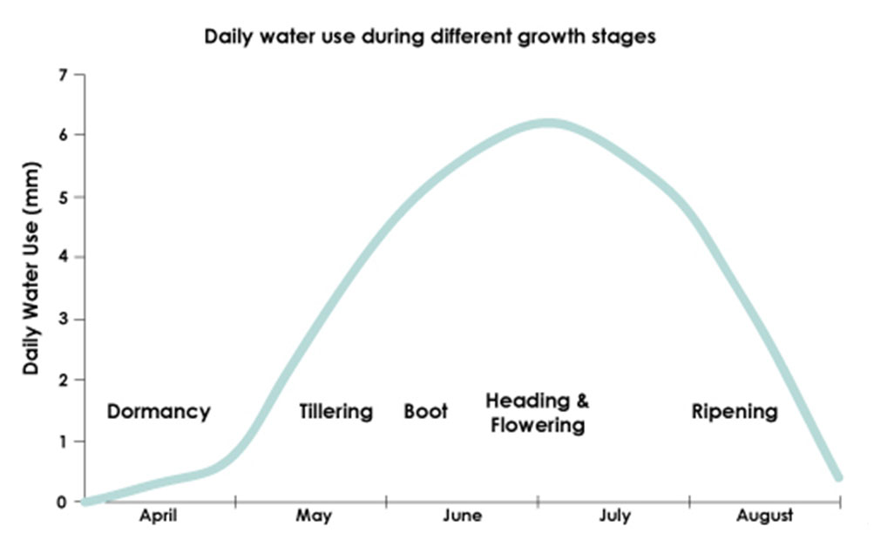

This graph is mapped into the following table. All the time periods are in reference to the minutes passed after sowing the seed.

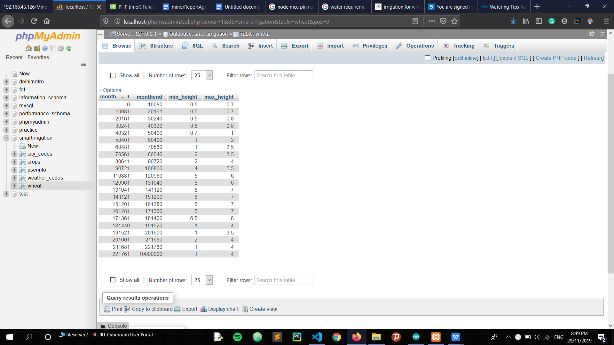

**5.1.2. Study of Rice:**

Rice is typically grown in bunded fields that are continuously flooded up to 7−10 days before harvest. Continuous flooding helps ensure sufficient water and control weeds. Lowland rice requires a lot of water. On average, it takes 1,432 liters of water to produce 1 kg of rice in an irrigated lowland production system. Total seasonal water input to rice fields varies from as little as 400 mm in heavy clay soils with shallow groundwater tables to more than 2000 mm in coarse-textured (sandy or loamy) soils with deep groundwater tables.

After studying the irrigation practices for rice cultivation from various research papers and agriculture blogs. We were able to quantify the following water requirement table for rice crop.

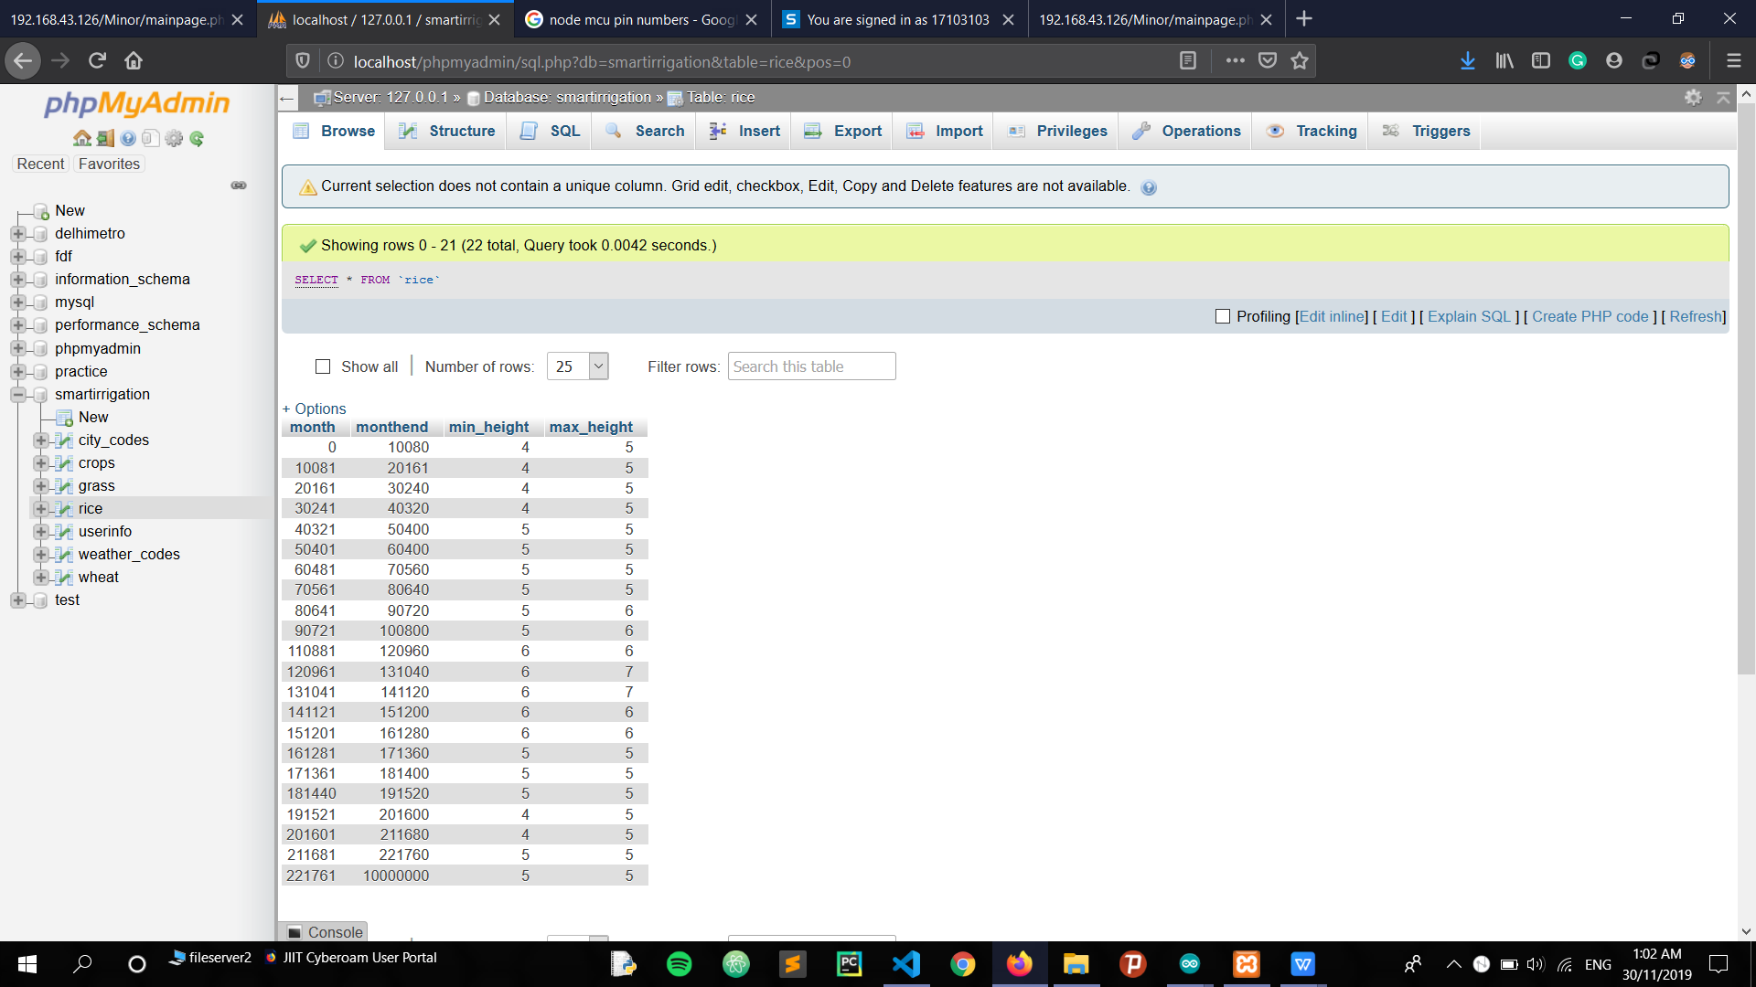

WATER NEED IN MM FOR TIME IN MINUTES AFTER SOWING

**5.1.3. Study of Grass:**

Water plays a key role in lawn and garden care. Nature doesn't always supply enough water, so your landscape may need a little help from you.The signs of a well-cared for yard are a green, weed-free lawn, healthy trees and healthy shrubs. They are an investment in the value of your property and should be protected.The question of how much to water and how often has no single answer. It depends on weather conditions, soil composition and the plants themselves. Grass is particularly susceptible since 85% of its bulk is water. A good drenching once or twice a week is better for your lawn than daily light sprinklings.This requires a long, thorough soaking of the soil, ideally to a depth of about 1 foot but at least 6 to 8 inches. A steady stream of water will run off. An even, sprinkling is best for deep penetration.

The following table structures the water requirement by lawn grass in various stages.

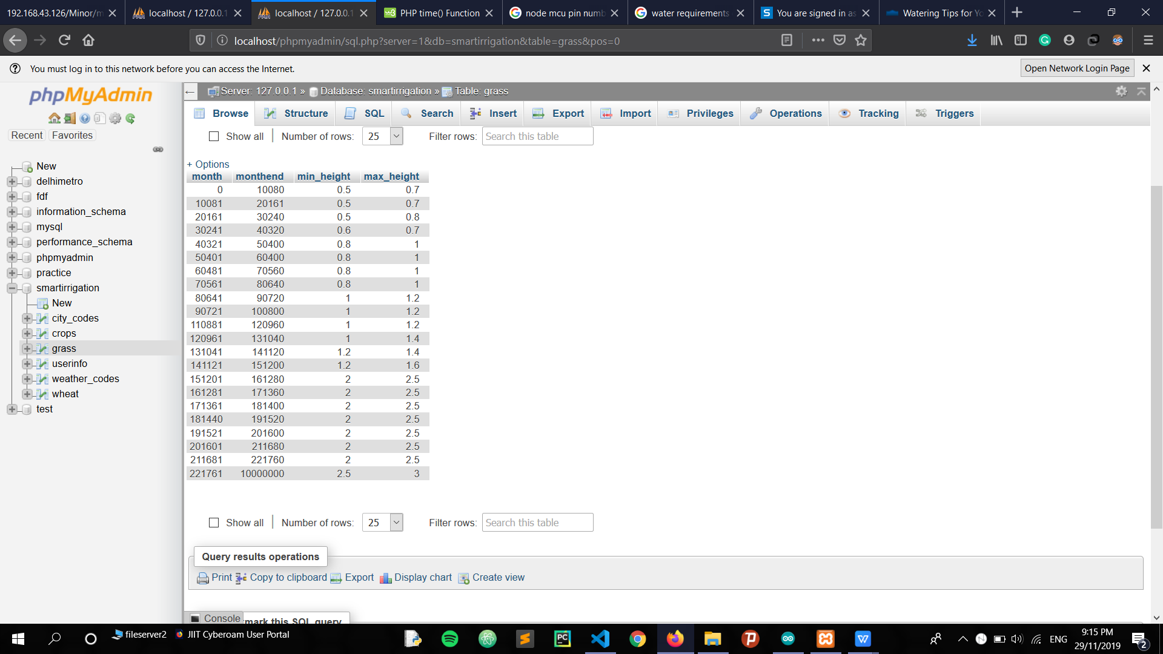

WATER NEED IN MM FOR TIME IN MINUTES AFTER SOWING

6. PROJECT PHASE - II

In this phase, we have redesigned the hardware architecture. The scale has been increased from two sensors to multiple sensors which can be modified by changing few variables. It also supports independent automated outlets, which are plug and play type. The user name simply add new machinery into the outlet and control it remotely using the interface.

**6.1. Hardware Implementation**

6.1.1 Devices used :-

* NodeMCU v1.0 : This is a micro-controller motherboard enabled with esp8266 Wi-Fi Soc. MCU stand for micro-controller unit. The firmware used Lua scripting language. In this project, this device works as the core of connections. This devices acts as a client sending requests to the server containing various properties asked by the server.
* 8-bit Relay Module: This device is used to as a switch between various connections, which is operated by pushing down the activation pins to low voltage. It works on the principle of electromagnetic induction in a coil.
* Analog Soil Moisture Reader: It measures the average value of moisture in dry soil or partially humid soil, by calculating the Di-electric constant value between the two probes of the device.
* 12V Water suction pump: It is used to demonstrate how water will be pumped into the fields depending on the outcome of server’s calculation of parameters.
* IC7805 and IC7809: IC7805 and IC7809 are used to convert the 12V from the adapter to 5V and 9V respectively. NodeMCU operates at 9V while relay operates at 5V.
* 12V single center shaft motor
* 12V LED strips
* 12V Adapter

6.1.2 Code Structure:

The complete is available at :

<https://github.com/FallenSage0614/Smart-Irrigation-Project/tree/master/HardwareCode>

NodeMCU restarts the code every time the power supply is resumed. It begins from the setup(). It assign the default values to the variables as are shown below and then initiates the network connection.

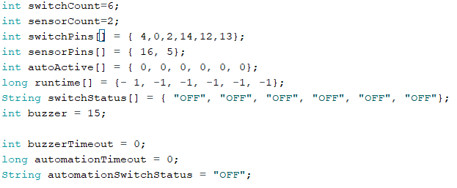

It is observable that the code can be altered by changing the value of sensorCount and switchCount. For this device, we have set the sensorCount to 2 and switchCount to 6. Other variables define the state of different machines connected to the outlets. A very prime function of the device is to request the server to provide the time to automate the irrigation system depending on the value of all the sensors ad average moisture content of the farm.

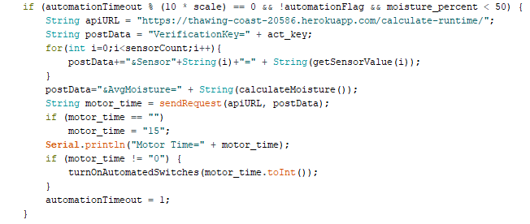

There are other utility function which are describes below with their corresponding functions:

|  |  |
| --- | --- |
| **Function Name** | **Function Description** |
| connectWifi() | Connects to server to the global internet |
| random() | Returns a random number between a and b |
| getString() | Extracts the keyword obtained in the request received. |
| getNumber() | Extracts the number obtained in the request received |
| getRuntime() | Returns the value of minutes received in the request to turn the motors on. |
| getIndex() | Returns the index of switch received in the request. |
| getStatus() | Extracts the status of the switch to obtained in the request from the global API. |
| sendJSONData() | Send the values of sensors ans switch status as a JSON data packet to the global server |
| getSensorValue() | Returns the value of the moisture sensor at the index passed in parameter. |
| setSwitch() | Set the switch value to the value passed in the parameter. |
| turnOffAll() | Turns off all the machinery in the beginning of the code. |
| turnOnAutomatedSwitches() | Turn on the switches whose status is set for automation. |
| turnOffAutomatedSwitches() | Turn off the switches whose status is set for automation. |
| sendDetails() | Send all the details of the present state of the farm to the global server. |
| calculateMoisture() | Calculates the average moisture value at the farm. |

The request received by the local server are GET requests in format. These request contain keywords which are managed by the below function and accordingly the required functions from the above mentioned functions are called.

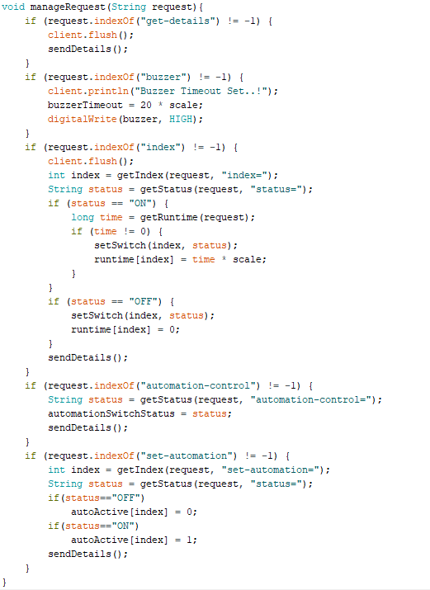

6.1.3 Circuit Diagram :-

The complete circuit diagram to support the code attached alongside is shown below. The below diagram defines the connection for managing 4 different types of motors, 2 light sources and 3 buzzers. It hosts 2 moisture sensors which sends data alternatively to the ESP8266 NodeMCU module, which acts as the local server.

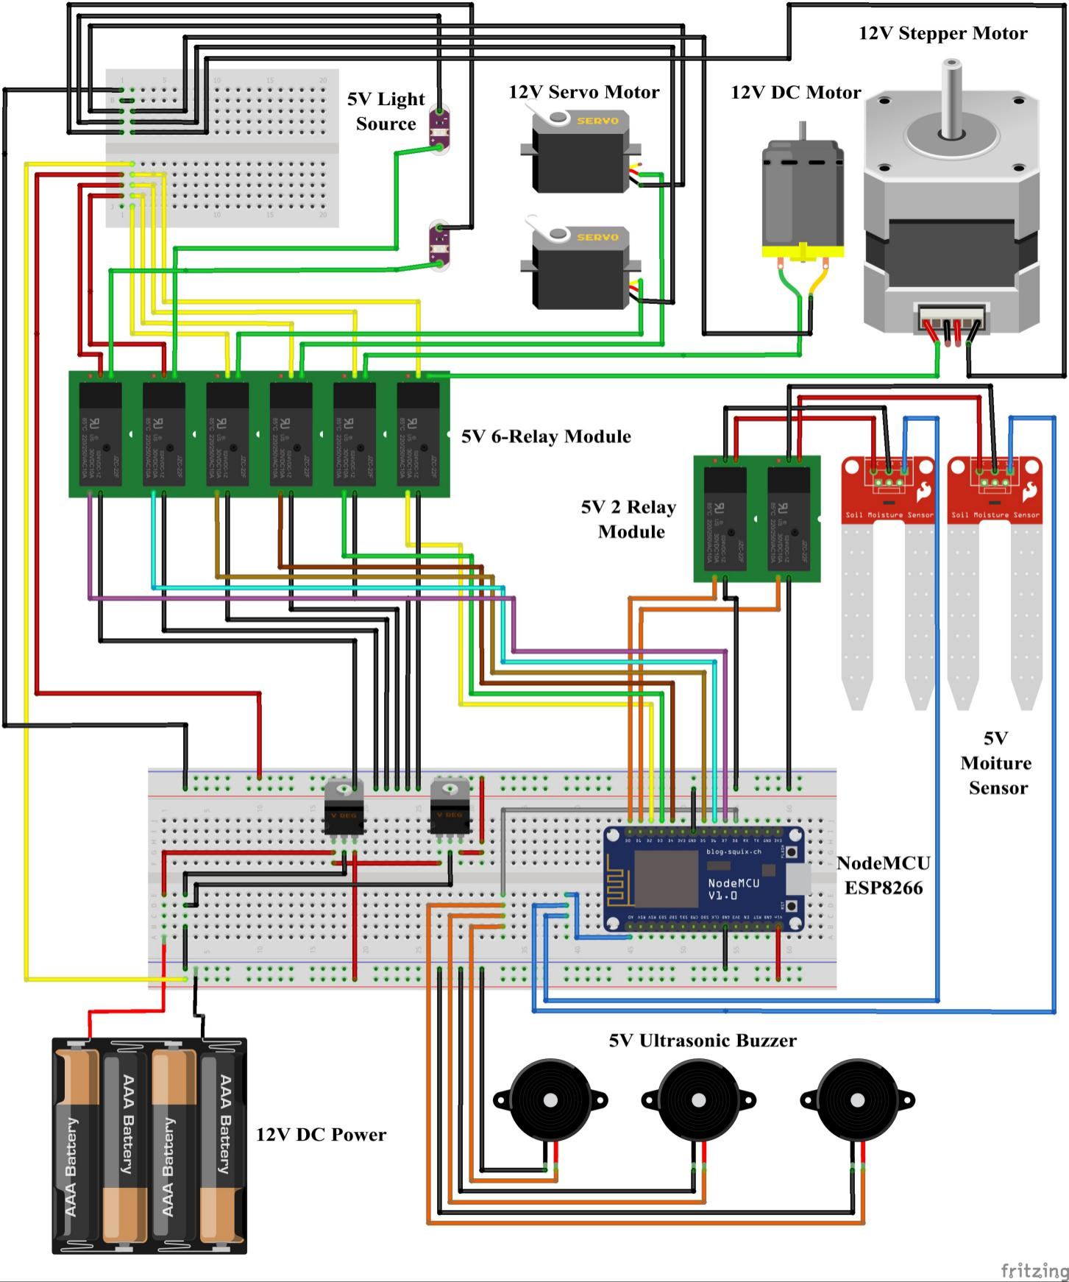

**Diagram representation of Hardware Mechanism**

**6.2. Software Implementation**